Knapsack :
Code:
#include <stdio.h>

#define MAX_ITEMS 100
#define MAX_CAPACITY 1000

int max(int a, int b)
{
return (a > b) ? a : b;
}

int main()
{
int n, capacity;
int weight[MAX_ITEMS], profit[MAX_ITEMS];
int dp[MAX_ITEMS + 1][MAX_CAPACITY + 1];

printf("Enter the number of items: ");
scanf("%d", &n);

printf("Enter the weights of %d items:\n", n);
for (int i = 0; i < n; i++)
{
scanf("%d", &weight[i]);
}

printf("Enter the profits of %d items:\n", n);
for (int i = 0; i < n; i++)
{
scanf("%d", &profit[i]);
}

printf("Enter the capacity of the knapsack: ");
scanf("%d", &capacity);

// Initialize first row and first column
for (int i = 0; i <= n; i++)
{
dp[i][0] = 0;
}

for (int w = 0; w <= capacity; w++)
{
dp[0][w] = 0;
}

// Build the DP table
for (int i = 1; i <= n; i++)
{
for (int w = 1; w <= capacity; w++)
{
if (weight[i - 1] <= w)
{
dp[i][w] = max(
profit[i - 1] + dp[i - 1][w - weight[i - 1]],
dp[i - 1][w]
);
}
else
{
dp[i][w] = dp[i - 1][w];
}
}
}

printf("\nMaximum profit = %d\n", dp[n][capacity]);

// Find selected items
printf("Selected items: ");

int w = capacity;

for (int i = n; i > 0 && w > 0; i--)
{
if (dp[i][w] != dp[i - 1][w])
{
printf("%d ", i);
w = w - weight[i - 1];
}
}

printf("\n");

return 0;
}

Output:
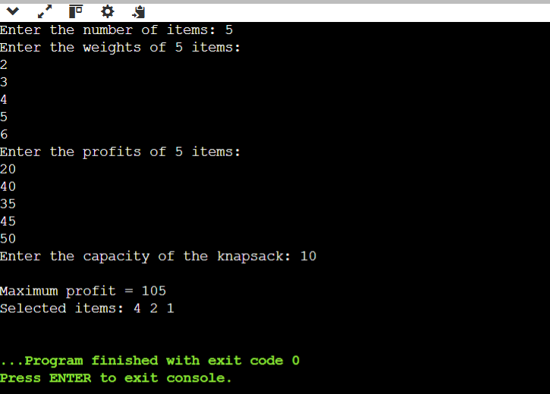
Conclusion:
Operation | Time Complexity | Space Complexity
Reading input | O(n) | O(n)
Initializing DP table | O(n × W) | O(n × W)
Filling DP table | O(n × W) | O(n × W)
Finding selected items | O(n) | O(1)
Overall | O(n × W) | O(n × W)

